Beneficiary Analysis:

The Braunstein Palace

**Braunstein Palace** is an architectural monument built at the beginning of the 20th century, more precisely in 1914, and due to its severe degradation state, has been consolidated and restored in 2018-2020.

A. Activity Profile : Managing Historical Buildings, Monuments and other Landmarks – CAEN code: 9103

The palace will serve both as monument and as library, events hall, art

B. Organisational Structure:

1. Staff (two-Shift structure)

|  |  |
| --- | --- |
|  | no. |
| Administrator | 2 |
| Secretary | 4 |
| Librarian | 8 |
| IT Technicians | 4 |
| Accountant | 2 |
| Janitors | 10 |
| Security Staff | 4 |
| Travel Guide ( contractors ) | Up to 10 |
| Event organizers | 6 |
| Volunteers + Interns | Up to 20 |
| TOTAL | 70 ( 30 temp. Staff) |

2. Guests: Up to 1000 at once.

C. Building Analysis: The building covers an area of roughly 3000sqm, has an irregular form and includes: one basement, one ground floor , three floors and an attic.

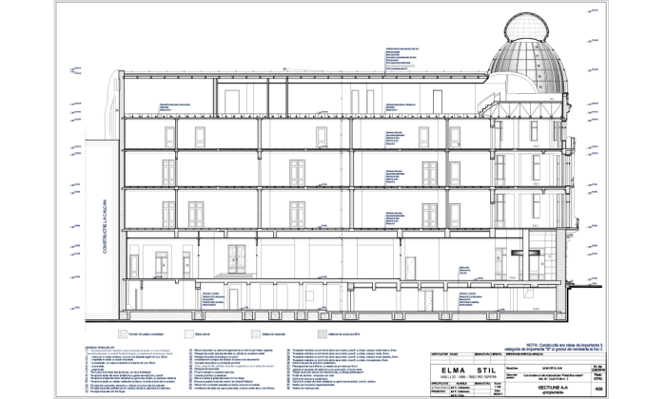

* Basement:
  + - * + One library provided with emergency exits (100 people max)
        + One bathroom
        + One elevator
        + One Hallway
        + One Media room / Mini Cinema (max 50 People)
        + One stairway
* Ground floor:
  + - * + One information center
        + Art Gallery ( 200 p. max)
        + One bathroom
        + Two stairways
* First Floor:
  + - * + 6 reading rooms
        + One hallway that will host temporary exhibits.
        + One Library
        + One bathroom
        + Two stairways
* Second Floor:
  + - * + 6 reading rooms
        + One hallway that will host temporary exhibits.
        + Board Room
        + One bathroom
        + One elevator
        + Two stairways
* Third floor
  + - * + Two conference rooms ( 200 P. max )
        + Two bathrooms
        + One IT Administration room
        + One elevator
        + Two stairways
* Attic
  + - * + One Auditorium (max 150)
        + Exhibit room
        + One bathroom
        + One elevator
        + One Stairway

D. Extra:

* For the Internet access using the Hotspots in the building, Each guest will be provided with either a one-time authentication token based on personal information. The same rule will apply in the case of using the Desktop Computers.
* The Staff and Contractors will receive an **username** and **password**.